**DEVEPOS**

DAY 2 Task

**Maven and Pipeline are created using windows**

* Installed Docker Desktop for Windows.
* Installed Jenkins on Windows.
* Installed Maven and added it to the system’s PATH.
* Installed required Jenkins plugins:
* Maven Integration Plugin
* Docker Pipeline
* Pipeline

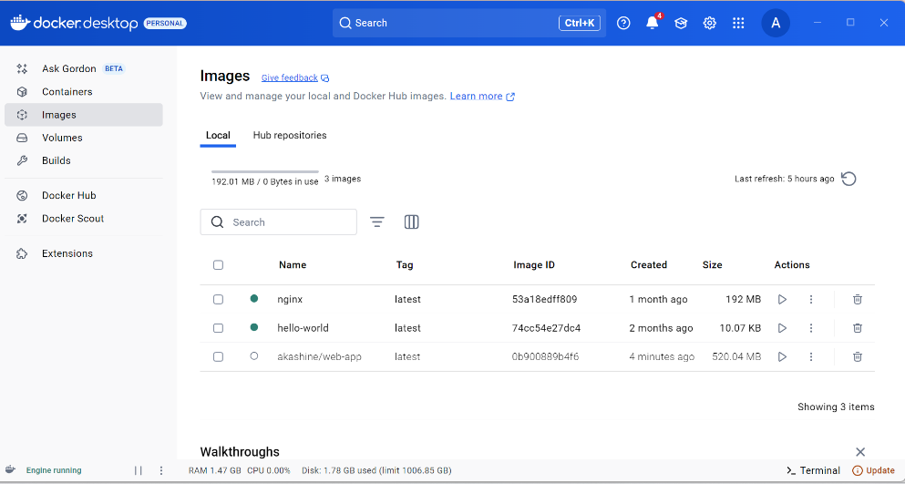

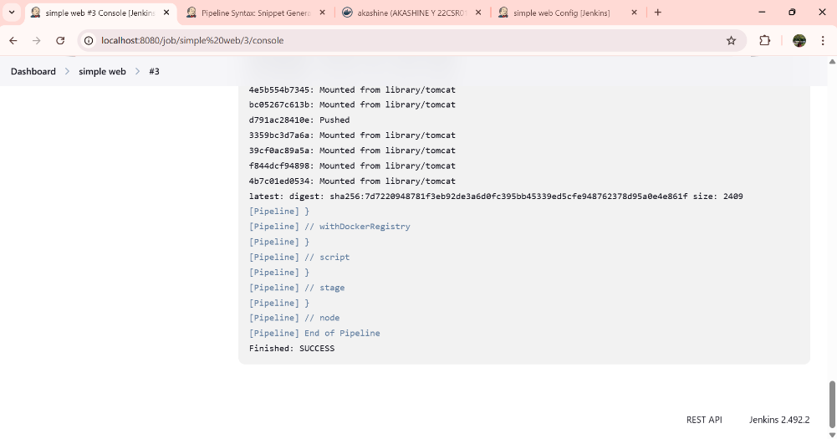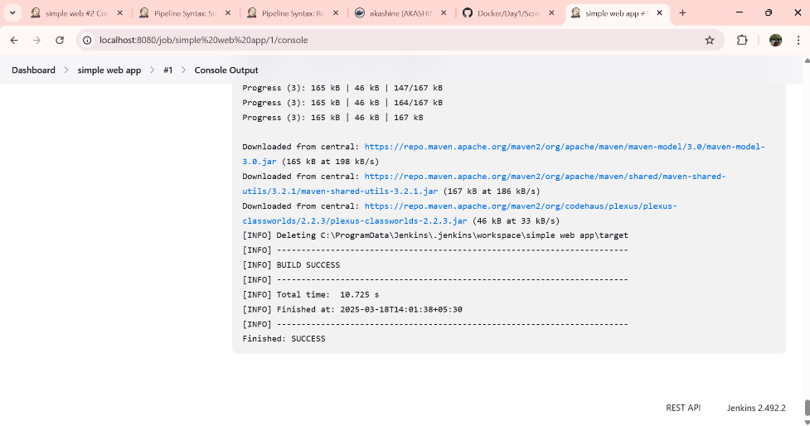

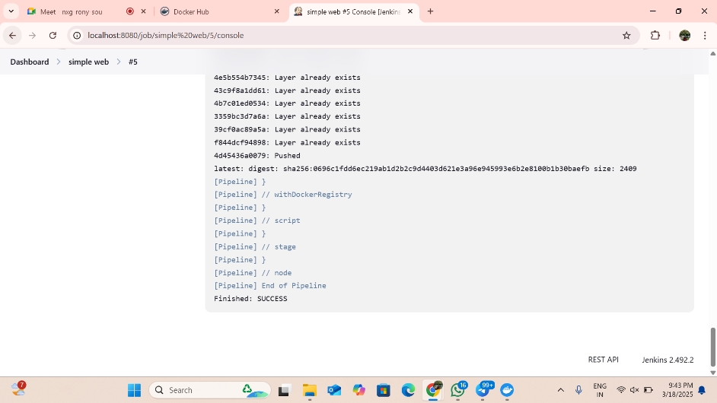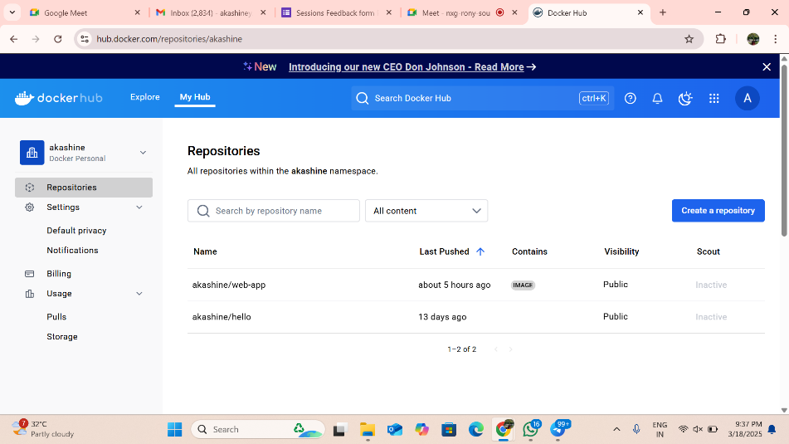

**Maven and Pipeline using linux**

1. Installed Docker:

* sudo apt update
* sudo apt install docker.io -y
* sudo systemctl start docker
* sudo systemctl enable docker

1. Installed Jenkins:

* sudo apt update
* sudo apt install openjdk-11-jdk -y
* wget -q -O - https://pkg.jenkins.io/debian/jenkins.io.key | sudo apt-key add -
* sudo sh -c 'echo deb http://pkg.jenkins.io/debian binary/ > /etc/apt/sources.list.d/jenkins.list'
* sudo apt update
* sudo apt install jenkins -y
* sudo systemctl start jenkins
* sudo systemctl enable Jenkins

1. Installed Maven:

* sudo apt install maven -y
* mvn -version

